Client / Owner: | Hamilton Wentworth Catholic District School Board
Contractor: |  | Atlantic Roofers Ontario Ltd.
Project Materials observed onsite: |  | N/A

Pretium was on site to review the progression of work. Only items observed by the reviewer and reported herein have been reviewed. Other conditions may be present that were not apparent to the reviewer at the time of the visit. The following was observed / discussed:
OBSERVATIONS / COMMENTS
- General
  - Original Estimated Project Completion Date: August 16, 2024 (weather permitting)
  - Projected Completion Date: Project Deemed Complete October 3, 2024.
KEY PLAN
NOT IN CONTRACT
CONTRACTOR STAGING/PARKING
ACTIVE WORK AREA AT TIME OF VISIT
COMPLETE TO NEW CAP SHEET MEMBRABRANE

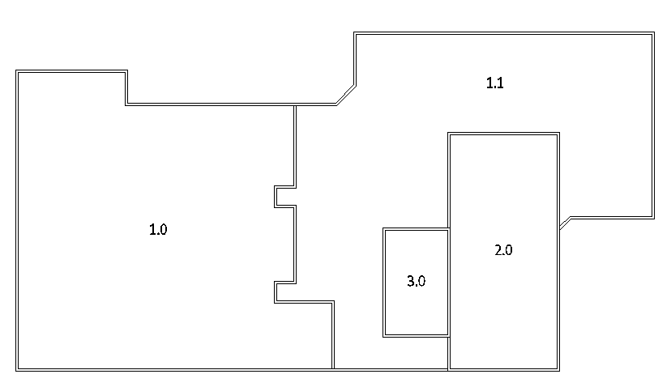
METAL FLASHING INSTALLED

  - The purpose of this visit was to walk the roof and note any deficiencies or other issues requiring attention prior to completion of the project. The walkover was attended by Nader Botros (HWCDSB), Harrison Karniej (HWCDSB), Joe Restivo (Atlantic), Camille Johnson (Soprema), Ryan Thornley (Soprema), and Dave Neal (Pretium). The following was observed and/or discussed. Pretium requested photographs of all completed repairs be forwarded by Atlantic to all parties. Atlantic agreed.
- Building Interior / Parking Lot / Landscaping
  - HWCDSB advised all suspended ceiling tiles damaged by leaks have been replaced. HWCDSB confirmed no additional action/remediation is required.
- New sod on the front lawn at the north side of the building used to repair damage caused by craning materials to the roof was reviewed. HWCDSB confirmed no additional action/ remediation is required. | 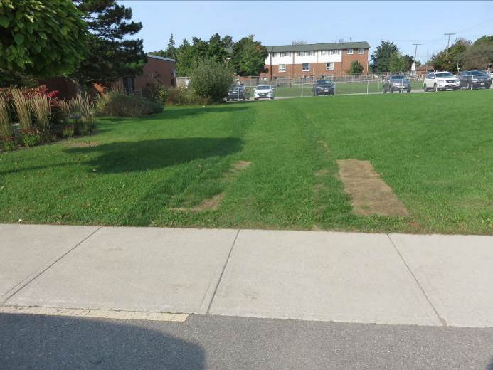
- Asphalt damage in the main parking lot at the north side of the building caused by the vacuum truck used to remove gravel from the roof was reviewed. HWCDSB confirmed no additional action/remediation is required. | 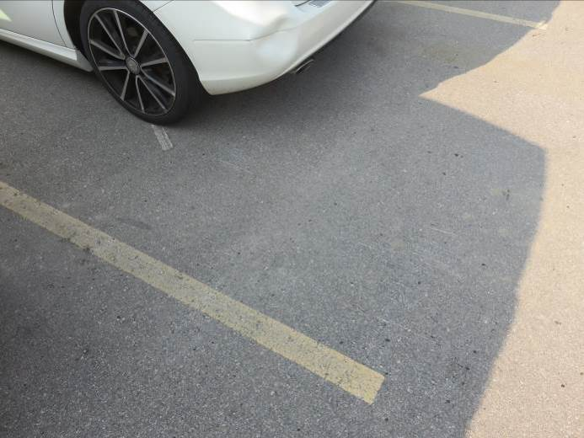

- All Roof Sections
- Overview of main roof (Sections 1.0 & 1.1) looking west. | 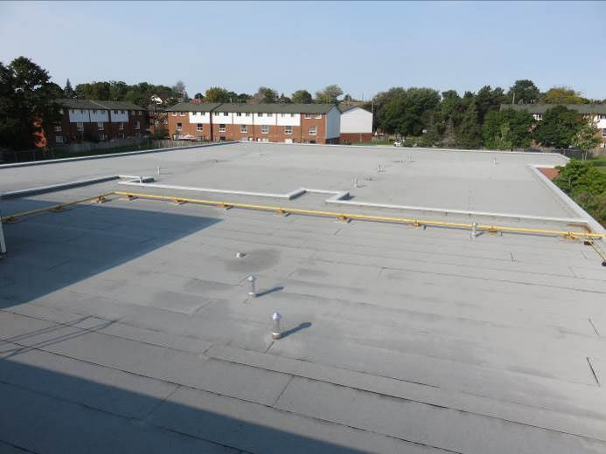
- Multiple small areas (approx. 12, typical) of minor membrane damage were observed on the main roof. Atlantic to repair with Alsan Flashing (liquid applied membrane) and ceramic granules. | 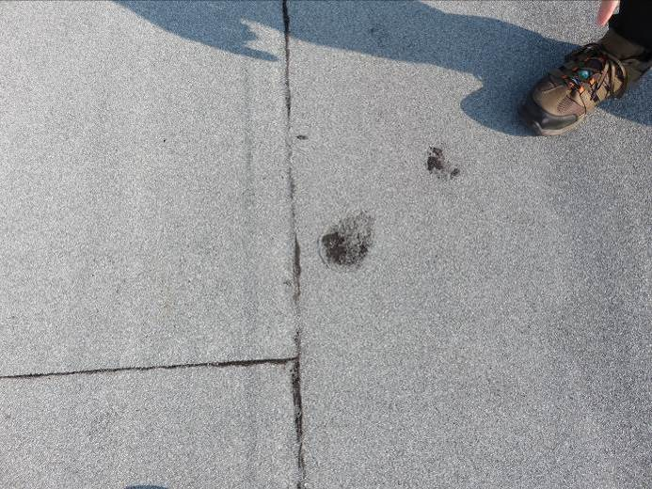
- The sealant in a Chem Curb flashing on Section 1.1 was low and the flashing was holding water. Atlantic to fill curb with additional sealant so the flashing does not hold water. | 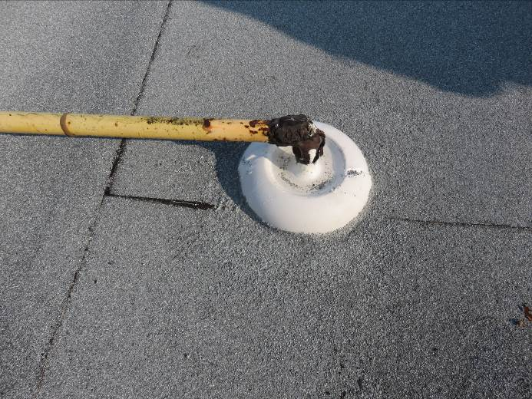
- An oil stain was observed on Section 1.1 and the membrane was soft/partially dissolved in this area. Atlantic to install a 2 ply membrane repair (base and cap) in this area. Final cap patch to be in min. 3’ widths and aligned with adjacent membrane rolls. | 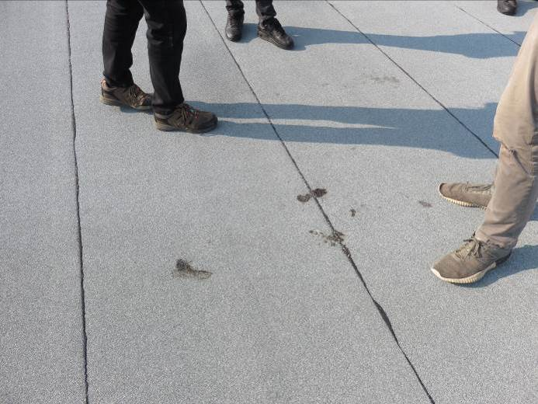
- Ponding or standing water was observed on Section 1.0 immediately west of the divider between Sections 1.0 & 1.1. Atlantic to install 2 additional plies of membrane (base and cap) in an approx. 6’x6’ area to reduce the depth of the ponded area and expedite drying after precipitation. | 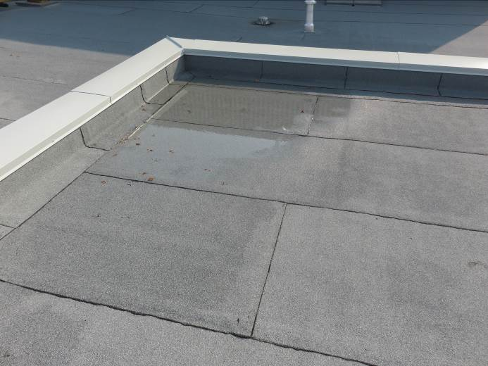
- Overview of gymnasium roof (Section 2.0) looking south. | 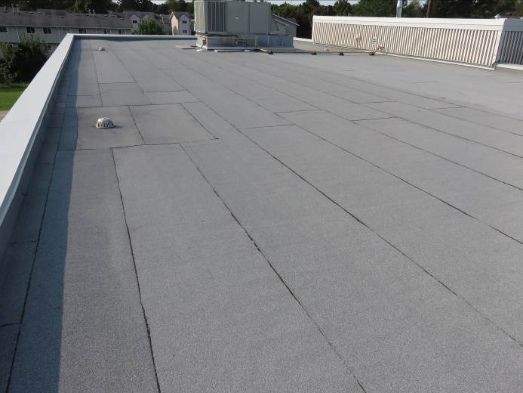
- Two areas of ponding or standing water were observed along the northern perimeter on Section 2.0. Atlantic to install 2 additional plies of membrane (base and cap) in an approx. 6’x6’ area at each location to reduce the depth of the ponded area and expedite drying after precipitation. | 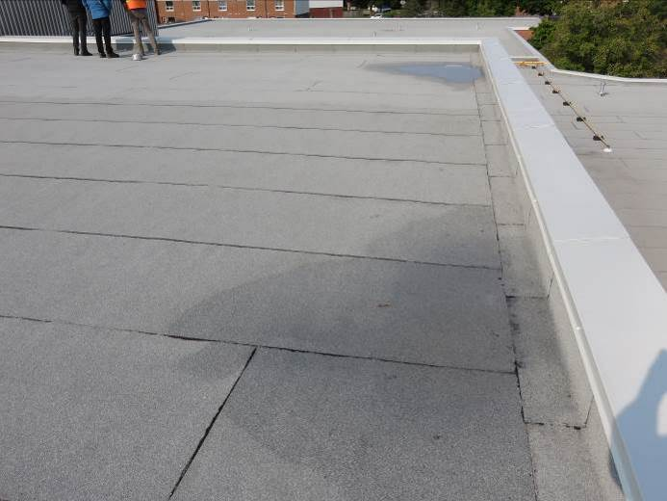
- Two areas of ponding or standing water were observed along the southern perimeter on Section 2.0. Atlantic to install 2 additional plies of membrane (base and cap) in an approx. 6’x6’ area at each location to reduce the depth of the ponded area and expedite drying after precipitation. | 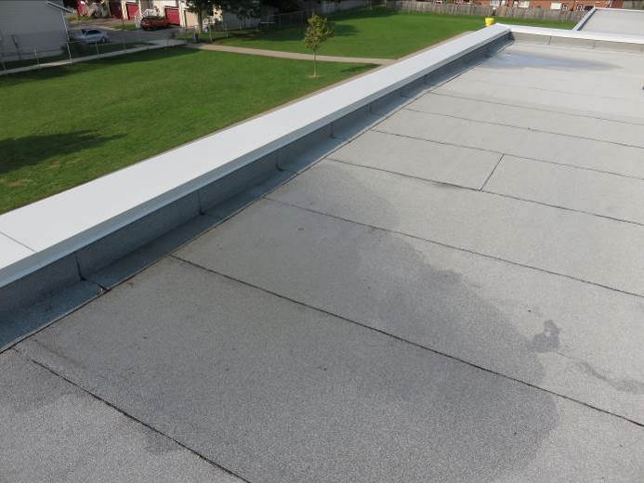
- Overview of mechanical penthouse roof (Section 3.0) looking north. | 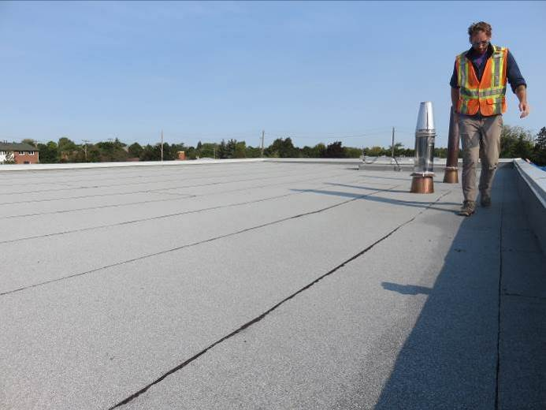
- Electrical fittings at base of curb are loose and susceptible to water infiltration. Atlantic to ensure connections are watertight. | 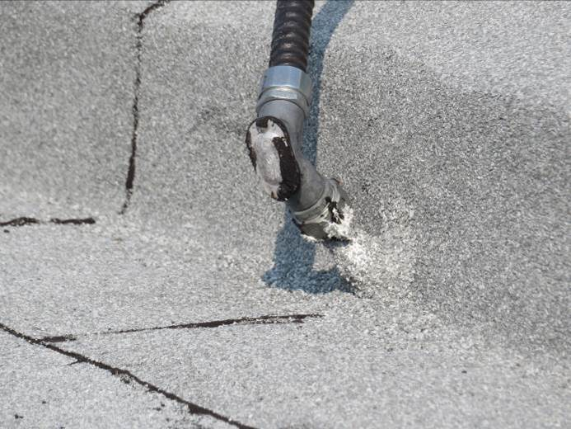

This report was issued to all parties on November 7, 2026.
Trade foreman was verbally notified of report contents. This report pertains to work specifically requested and comments only on operations and items that were visible or being undertaken at the time of our inspection.
Report by: | Dave Neal, H.Dipl.T., RRO

